Extreme Networks ExtremeXOS Virtual Machine with Oracle VirtualBox

Installation Guide

**Abstract:** This document provides a step-by-step instructions for installing the ExtremeXOS VM image on VirtualBox

Published: August 2015

Extreme Networks, Inc.   
145 Rio Robles  
San Jose, California 95134  
Phone / +1 408.579.2800  
Toll-free / +1 888.257.3000

[www.extremenetworks.com](http://www.extremenetworks.com)

© 2012–2015 Extreme Networks, Inc. All Rights Reserved.

AccessAdapt, Alpine, Altitude, BlackDiamond, Direct Attach, EPICenter, ExtremeWorks Essentials, Ethernet Everywhere, Extreme Enabled, Extreme Ethernet Everywhere, Extreme Networks, Extreme Standby Router Protocol, Extreme Turbodrive, Extreme Velocity, ExtremeWare, ExtremeWorks, ExtremeXOS, Go Purple Extreme Solution, ExtremeXOS ScreenPlay, ReachNXT, Ridgeline, Sentriant, ServiceWatch, Summit, SummitStack, Triumph, Unified Access Architecture, Unified Access RF Manager, UniStack, XNV, the Extreme Networks logo, the Alpinelogo, the BlackDiamond logo, the Extreme Turbodrive logo, the Summit logos, and the Powered by ExtremeXOS logo are trademarks or registered trademarks of Extreme Networks, Inc. or its subsidiaries in the United States and/or other countries.

sFlow is the property of InMon Corporation.

Specifications are subject to change without notice.

All other registered trademarks, trademarks, and service marks are property of their respective owners.

For additional information on Extreme Networks trademarks, see [www.extremenetworks.com/company/legal/trademarks](http://www.extremenetworks.com/company/legal/trademarks).

PART# 121102-00

Initial

Initial

**Summary**

This document provides instructions on how to create and install an ExtremeXOS (EXOS) Virtual Machine (VM) on VirtualBox 5.0 running on Windows 7. The steps for installing using other versions and OS’s is similar.

The EXOS VM running in VirtualBox simulates a Summit series switch with the following virtual hardware features:

* 256 MB flash for OS image, configuration and policy files
* 256 MB of Memory
* 1 out-of-band management port
* Up to 7 front-panel ports

**Prerequisites**

* Oracle VirtualBox version 5.0 or greater

The Oracle VirtualBox application is a free virtualization software package that is available for a variety of host operating systems including Linux, Mac OS X, and Windows.

The latest VirtualBox installation packages including installation instructions can be downloaded from <http://www.virtualbox.org/wiki/Downloads>

* EXOS ISO image (e.g. exospc-xx.x.x.x.iso)

This EXOS ISO file is a bootable CD-ROM image that can be used as a virtual installation CD with a variety of virtual machine applications.

The latest EXOS ISO image can be downloaded from

<https://github.com/extremenetworks/xkit>

**EXOS VM VirtualBox Installation**

1. **Create New Virtual Machine**

Click “New” In the Oracle VM VirtualBox Manager Window to start the” Create Virtual Machine” wizard:

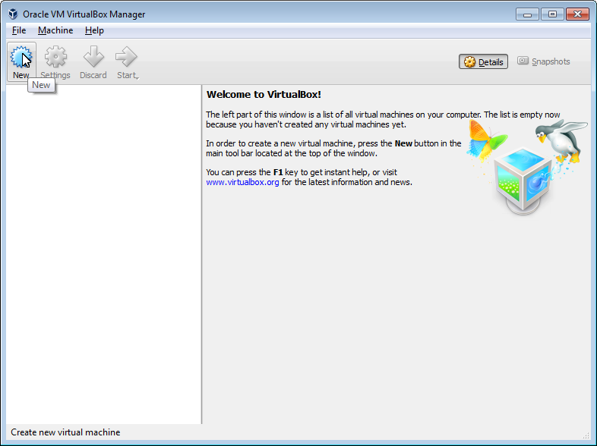

1. **Name and operating system**

In the “Create Virtual Machine” windows enter a name for the VM, select Type: “Linux” and select Version “Other Linux (32-bit)” and then click “Next”

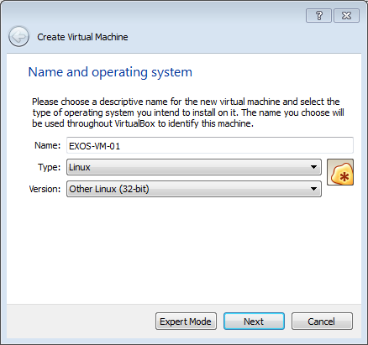

1. **Memory size**

Click “Next” to accept the default memory size of 256 MB

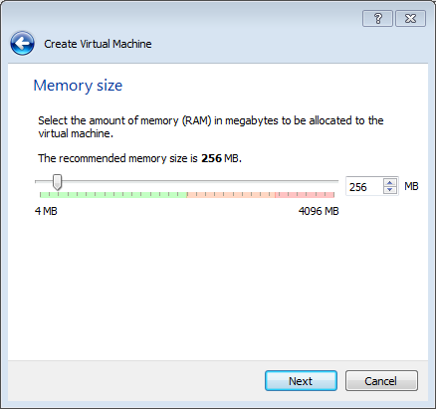

1. **Hard disk**

Click “Create” to create a virtual hard disk for the VM

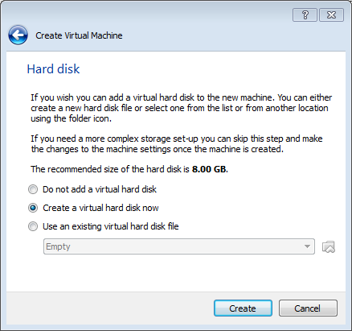

1. **Hard disk file type**

Click “Next” to accept the default “VDI” Hard Disk file type:

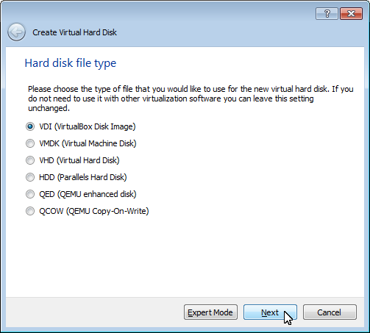

1. **Storage on physical hard disk**

In the “Storage on physical hard disk” panel select “Fixed size” and click “Next”:

|  |
| --- |
| Note |
| Alternatively “Dynamically Allocated” can be selected as the EXOS installation will format the entire disk so there is a negligible difference between the two options. |

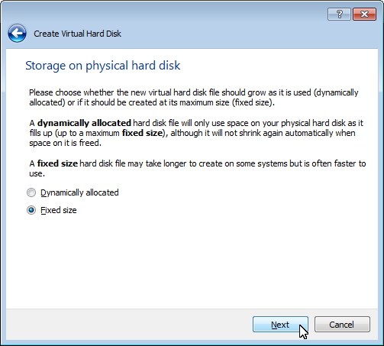

1. **File location and size**

Set the size of the virtual hard disk to 256 MB and click “Create”

|  |
| --- |
| Note |
| The name and location of the virtual hard disk file can be changed by clicking the icon. |

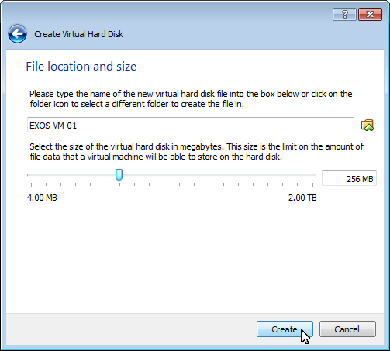

1. **Mount the EXOS ISO image**

Right clicking on “Optical Drive” under the “Storage” pane in the VirtualBox Manager window and then select “Choose disk image”

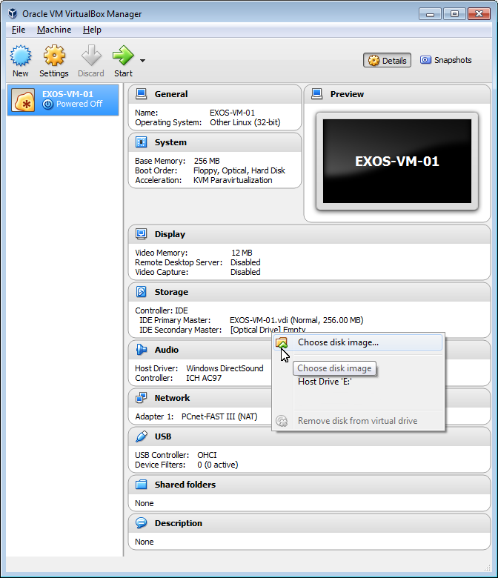

1. **Choose a virtual optical disk file**

Select the exospc-x.x.x.x.iso image to be installed

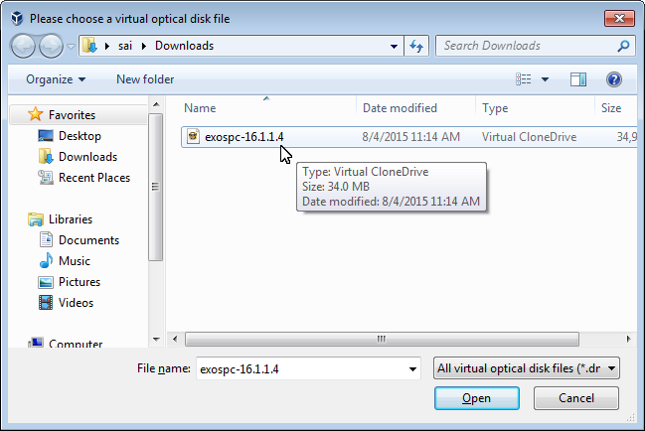

1. **Power on the VM**

Click the “Start” in the VirtualBox Manager window

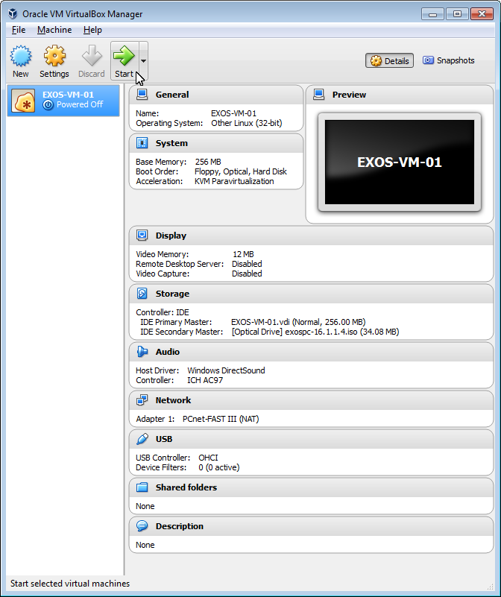

1. **Select start-up disk**

From the pull-down menu select exospc-x.x.x.x.iso image to be installed and then click “Start”

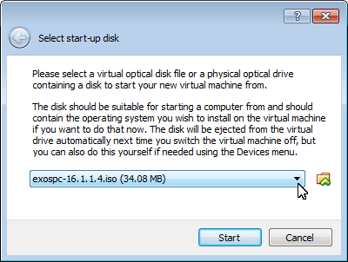

1. **Install image using “Rescue Mode”**

At the “Ok to continue” prompt enter “Y” to initiate EXOS installation

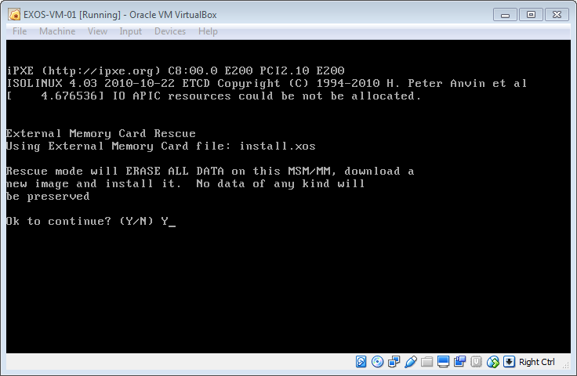

1. **Unmount the EXOS ISO and reboot**

Once installation is completed unmounts the image by selecting *Devices>Optical Drives>Remove disk* from virtual drive then press ENTER to reboot the VM

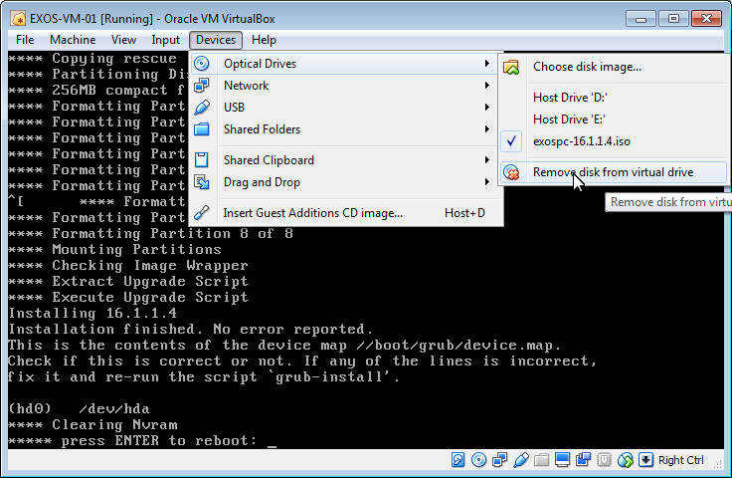

1. **Verify installation**

Confirm successful installation by login into switch using the factory default login:

*User = admin*

*Password: <null>*

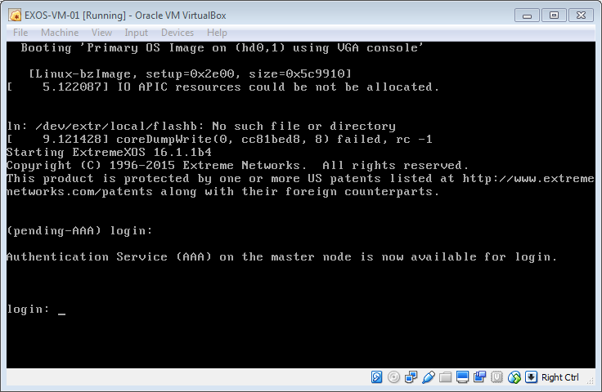

|  |
| --- |
| Note |
| A “*(pending-AAA) login*:” prompt is displayed on the switch console while the switch is completing the boot up process. You must wait for the following message to be displayed in order to log into the switch:  “*Authentication Service (AAA) on the master node is now available for login”* |

|  |
| --- |
| Note |
| An “*IO APIC resources*” and “*No such file or directory*” error message may be appear on the console during bootup. The errors are similar to the following:  *“IO APIC resources could not be allocated”*  “*/dev/extr/local/flashb: No such file or directory*  *[ 25.180000] coreDumpWrite(0, cc9f7ed8, 8) failed, -1”*  These message will not affect the EXOS switch operations and can be ignored |

**EOS VM VirtualBox Network Configuration**

An EXOS Virtual machine running in VirtualBox supports one out-of-band management Ethernet port and up to 7 front-panel Ethernet ports. VirtualBox support eight virtual network adapters. The first 4 virtual adapters can be configured in the “Network” section of the VirtualBox GUI. The additional 4 virtual network adapters are configured using the VirtualBox CLI (VBoxManage).

|  |
| --- |
| Note |
| Alternatively all virtual adapters can be configured using VBoxManage.  See Appendix A |

The first virtual network adapter (Adapter 1) maps to the EXOS VM management port and is enabled by default. The additional virtual network adapters, once enabled, map sequentially to the “front–panel” ports on the EXOS VM (i.e. Adapter 2>port 1, Adapter 3-> port 2, etc.). In order for the front-panel ports to accept all traffic they must be configured in promiscuous mode.

Each virtual network adapter can be configured to use one of several “networking modes”. Typically for EXOS VM configurations the networking modes used are “Bridged networking” and “Internal Networking”. Bridged mode is used to map a virtual network adapter to a host’s physical adapter. Internal mode is used to create software-based networks internally with the VirtualBox virtual environment.

|  |
| --- |
| Note |
| Detailed information on VirtualBox networking modes and VirtualBox virtual networking can be found at the following link:  <https://www.virtualbox.org/manual/ch06.html> |

A common configuration is to configure Adapter 1 (management port) as a "Bridged Adapter" mapped to a physical adapter on the VirtualBox host. This allows direct telnet access to the EXOS VM via the management port IP address and additional switch management tasks such as EXOS upgrades and configuration uploads and downloads directly to external network devices.

The remaining virtual network adapters, which map to the front-panel ports are then configured to use Internal Networking, mapping each adapter to a separate internal network. EXOS VMs can be interconnected by selecting the same internal network on a network adapters on each EXOS VM creating a direct virtual point-to-point link. The virtual network adapters can also be configured to use internal networks to connect other client and server VMs or physical devices using bridged mode.

Things to Note:

* Each virtual adapter maps to one port on the switch
* Enabling a virtual adapters adds ports to the EXOS VM switch
* First virtual adapter always maps to the Mgmt port
* All ports MUST be of same Adapter types for port ordering
* Adding EXOS VM virtual adapters to the same internal network can create loops. Use a unique Internal Network name when mapping a virtual adapter to an internal network. (Exceptions include interconnecting EXOS VMs which need to use the same port group and port load-sharing)
* To interconnect two or more EXOS VM switches use the same internal network name on a virtual adapter on each EXOS VM

|  |
| --- |
| Note |
| The EXOS VM needs to be powered off to perform the following Network configurations |

1. **Edit network settings**

In the VirtualBox Manager Window click on “Network” to open the Network Settings window.

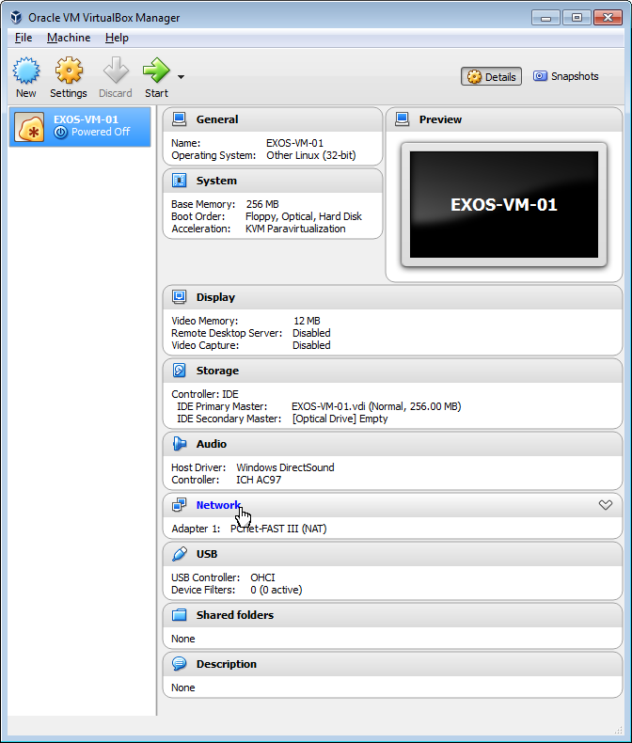

1. **Configure Network Adapter 1**

In the Adapter 1 tab (EXOS VM Mgmt port) set the “Attached to” setting to “Bridged Adapter”

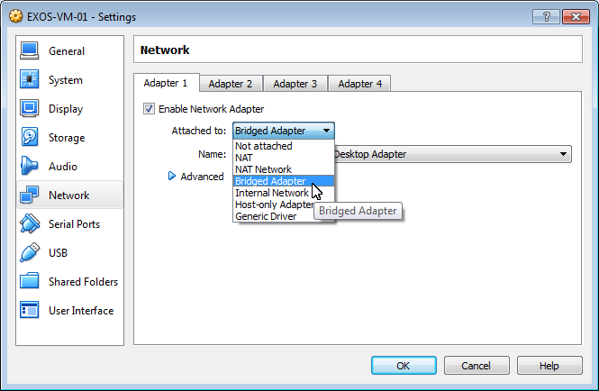

1. **Select Adapter for switches Mgmt port**

Select the name of the physical adapter name that will be used to bridge traffic

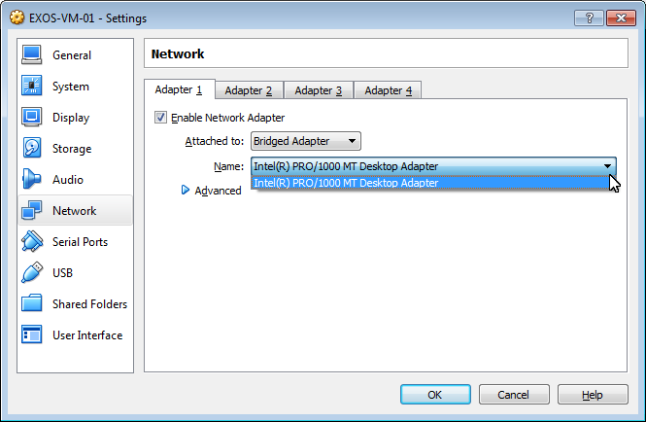

1. **Configure Network Adapter 2**

Select the “Adapter 2” tab and select the “Enable Network Adapter” checkbox:

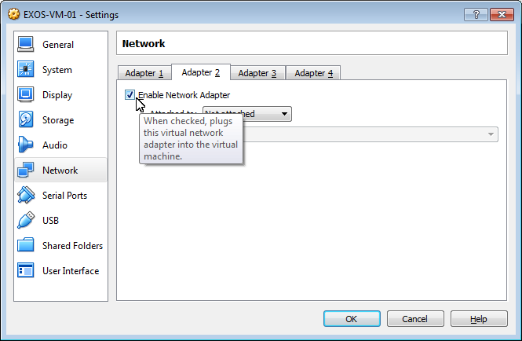

1. **Select internal network for switch port 1**

Set the “Attached to” setting to “Internal Network” and set the “Name” to Link-A

|  |
| --- |
| Note |
| Optionally the system created default Internal Network “intnet” can be used or another name of your choice |

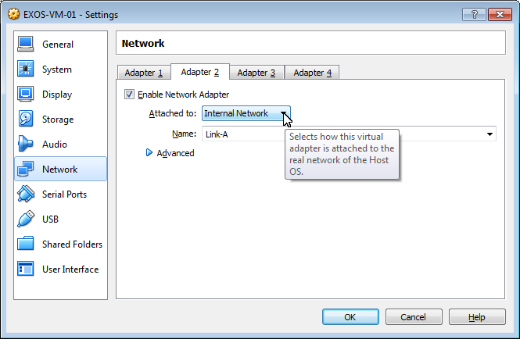

1. **Adapter 2 advanced settings**

Expand the “Advanced” settings by clicking on the blue arrow:

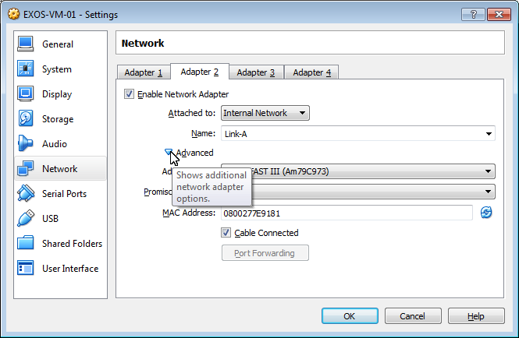

1. **Promiscuous mode**

Set “Promiscuous Mode” to “Allow All”

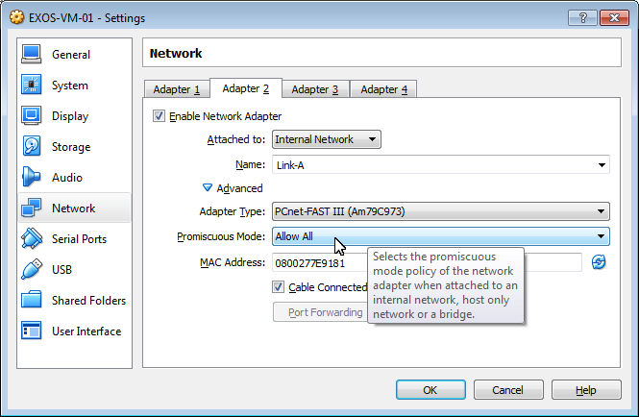

1. **If needed, repeat steps for Adapters 3-4**

Repeat steps 4 – 7 for Adapters 3 and 4 if required. Use a different internal network name for each adapter to avoid loops.

|  |
| --- |
| Note |
| See Appendix A for steps on configuring virtual adapters 5 – 8 using the VirtualBox CLI (VBoxManage) |

1. **Review Settings**

Click “Ok” to accept and commit the settings

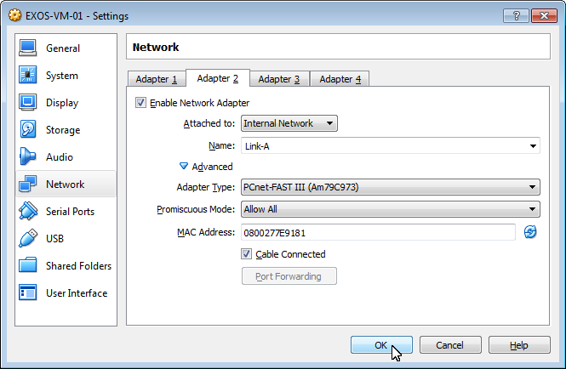

1. **Power on VM**

Click Start to power on VM

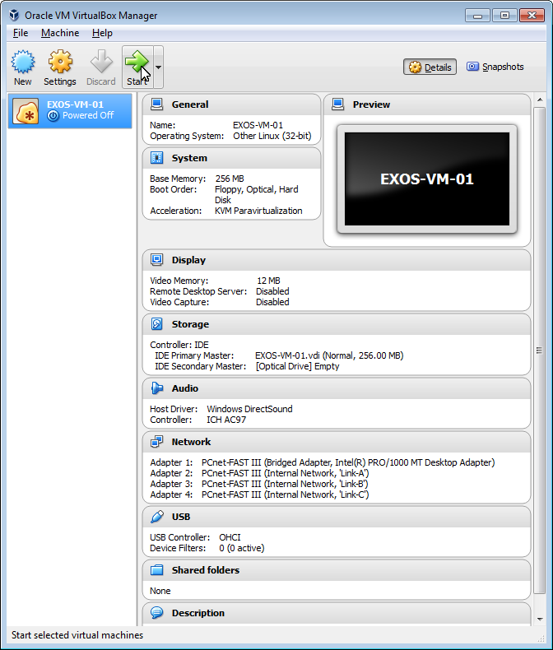

1. **Select start-up disk**

From the pull-down menu select the



1. **Verify switch interfaces**

Once switch boots login and issue a “show port” to verify that the correct number of ports were created:

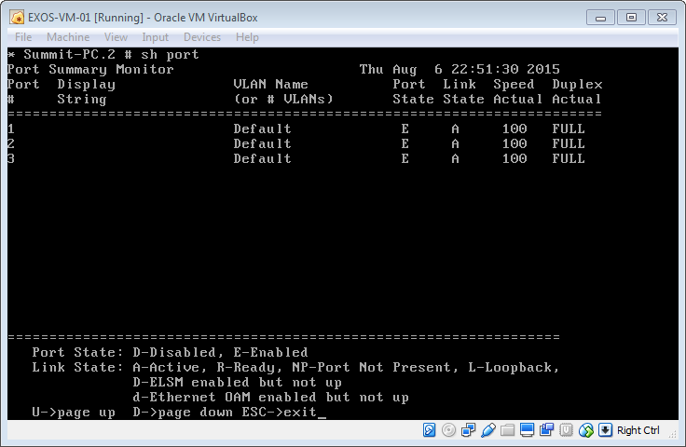

**Appendix A: Network Settings using VBoxManage**

VBoxManage is the command-line interface to VirtualBox. This CLI provides full control

of VirtualBox running on the host operating system. VBoxManage supports all the

Features available in VirtualBox Manager GUI plus additional features not available in

the GUI. VBoxManage commands are run from the VirtualBox installation directory. The default directory on a Microsoft Windows installation is:

*C:\Program Files\Oracle\VirtualBox*

This section provides steps for configuring virtual adapters using the CLI,

More specifically virtual adapters 5 – 8 as these are not configurable using the GUI.

However all virtual adapters can be configured using the CLI

Additional information on VBoxManage can be found on the following link:

<https://www.virtualbox.org/manual/ch08.html>

|  |
| --- |
| Note |
| These commands require that the VM be powered (i.e. not running nor in "saved" state). In addition the VirtualBox Manager GUI application must be closed in order for these CLI commands to take effect and be stored in the configuration. |

To configure the virtual adapters the following VBoxManage “modifyvm” commands will be used

--nic<1-N> none|null|nat|natnetwork|bridged|intnet|hostonly|generic

Sets the “Attached to” setting of the virtual adapter

--intnet<1-N> <network name>

Sets the Internal Network name

--nicpromisc<1-N> deny|allow-vms|allow-all

Sets the the promiscious mode

showvminfo <vm name>

Displays information for VM

1. Open a command prompt window and change to the VirtualBox installation directory

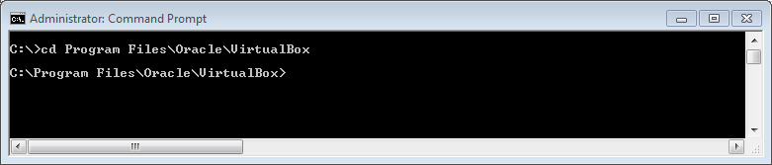

1. At the command prompt type “*vboxmanage modifyvm EXOS-VM-01 --nic5 intne*t” and press “enter”

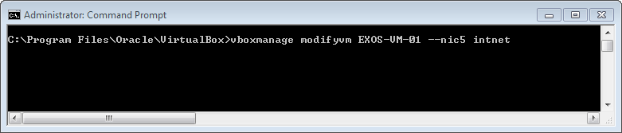

1. At the command prompt type “*vboxmanage modifyvm EXOS-VM-01 --intnet5 Link-D*” and press “Enter”

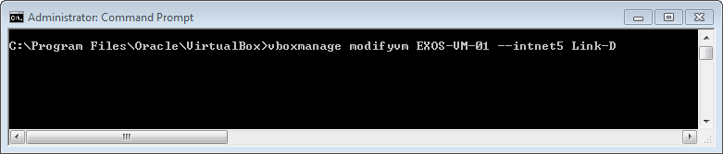

1. At the command prompt type “*vboxmanage modifyvm EXOS-VM-01 --nicpromisc5 allow-all*” and press “Enter”

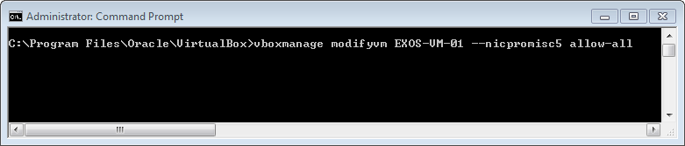

1. At the command prompt type “*vboxmanage showvminfo EXOS-VM-01*” and press “Enter” to verify “virtual adapter “ NIC” configuration

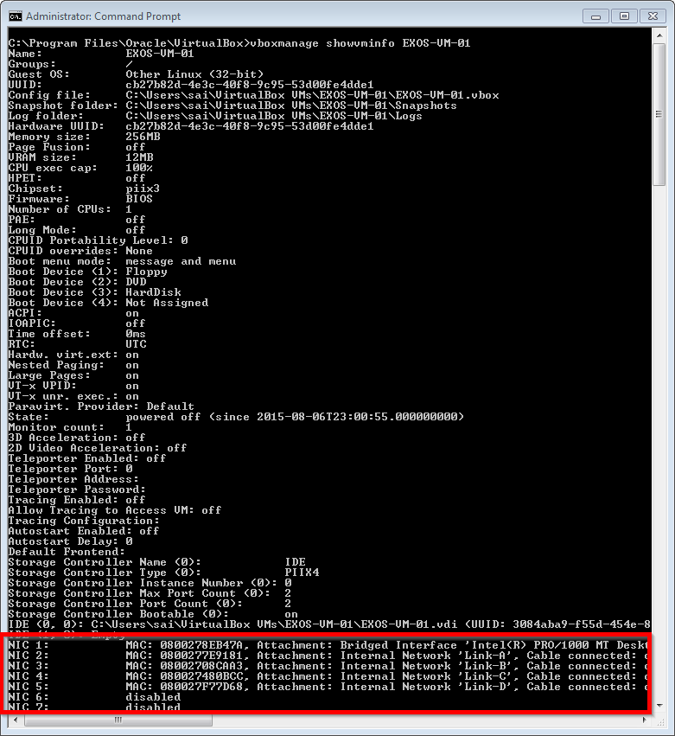

# Terms & Condition of Use

Extreme Networks Networks, Inc. reserves all rights to its materials and the content of the materials.  No material provided by Extreme Networks Networks, Inc. to a Partner (or Customer, etc.) may be reproduced or transmitted in any form or by any means, electronic or mechanical, including photocopying and recording, or by any information storage or retrieval system, or incorporated into any other published work, except for internal use by the Partner and except as may be expressly permitted in writing by Extreme Networks Networks, Inc.

This document and the information contained herein are intended solely for informational use. Extreme Networks Networks, Inc. makes no representations or warranties of any kind, whether expressed or implied, with respect to this information and assumes no responsibility for its accuracy or completeness. Extreme Networks Networks, Inc. hereby disclaims all liability and warranty for any information contained herein and all the material and information herein exists to be used only on an "as is" basis. More specific information may be available on request. By your review and/or use of the information contained herein, you expressly release Extreme Networks from any and all liability related in any way to this information.   A copy of the text of this section is an uncontrolled copy, and may lack important information or contain factual errors. All information herein is Copyright ©Extreme Networks Networks, Inc. All rights reserved. All information contain in this document is subject to change without notice.

For additional information refer to: [http://www.Extreme Networks.com/constants/terms-of-use.aspx](http://www.enterasys.com/constants/terms-of-use.aspx)